2024 Staley Meadows HOA Annual Meeting
Thursday, November 14, 2024

Jeff introduced Current Board Member:
- President - Jeff Tittor
- Vice President - Jess Ortiz, not present
- Treasurer – Linsey Ferrel
- Secretary – Janet Knapp
- Open Lands – Annette Newsom, not present
Jerry Vick and Eric Beanland introduced. They are members from Architecture Committee
2025 Projected Budget w/ Vendor Costs (hand outs)
Jeff reviewed 2024 spending & comparison budget for 2025. Detailed spending and budget indicates shortfall.
Total Revenues - $116,073.00
Total Expenses - $132,765.79
Total Shortfall - $16,692.79

Jeff discussed the reality of our HOA. Staley Meadows is land locked, which means no potential additional revenues (dues from additional homes). We need to expect annual dues to increase as long as costs increase.
Too many open land areas that need to be addressed. Not enough money to do them all. The Board requesting home owners input to help in prioritizing areas. Special meeting will be held late Winter/early Spring to make decisions.

Requests for Cost Savings Ideas / Brainstorming from Homeowners

- Villa’s budget has $5000 for snow - if not used $ could be a carry over which will reduce the Special Assessment amount.
- Look for a homeowner / retiree with a zero turn mower ???
- Offer neighboring Staley Heights HOAs to partner with our HOA. Their open lands could end up being very expensive. Not sure when/if their pool is going in. Concerns were expressed regarding maximum capacity at our pool if we merged.

- Reduce load of Board Members to avoid costs of Management Company, Treasurer is most burdened.

- Traveling to PO Box is time consuming.
  - Investigate a mailbox at the neighborhood pool (vs $348 each year for PO Box)
- Check payments more laborious than electronic payments
  - Request Villa members pay dues once a year by check OR pay monthly dues electronically.

Discussion of Bylaws needing updated & enforced

Jeff explained inconsistent enforcement of the restrictions have taken place over the years.
Jeff would like some homeowners to look at current bylaws and create draft before asking homeowners to vote. Large percent of homeowners will need to approve the update.Please email staleymeadowshoa@gmail.com if you are interested
*** Eric Beanland volunteered

Open Board Member positions for 2025 is Open Lands:
Open Lands (At Large)
- This position is responsible for working with the Vendors for the maintenance of the open lands, common areas and pond.
- Manages the lawn care, landscaping, mowing, weeding, pond maintenance of the neighborhood and snow removal of the Villas.
- This role is also responsible for procuring bids for contractors of these services as well as managing and interacting with the contractors, including following up with vendors as homeowners have feedback.
- Responsible for scheduling Neighborhood Clean Up Days (Spring/Fall) as needed.
- Responsible for responding to neighborhood requests regarding open lands
- Responsible for retention pond areas
- Reviews and approves Architecture Request Forms submitted by homeowners; ensures homes follow design, color and construction as defined by the bylaws.
Jeff asked if anyone had any questions about roles and responsibilities of Board Members - no questions. Jerry Vick volunteered to take the Open Lands Board position when it opens in the Spring of 2025.

Q & A

Homeowner expressed appreciation to the board. She thanked them for the volunteer work they are doing.

Homeowner asked if anyone else was bothered by a parked trailer violation in the neighborhood. It has been an issue for over a year. She asked what could be done. Janet encouraged her to submit the known violation formally to staleymeadowshoa@gmail.com for the board to address.

Action Items -

- Schedule a meeting late Winter /early Spring to address open land needs and plan of attack.
- Look into the USPS Locked Mailbox to be located at the Pool address.
- Inform Villa owners - Beginning 2025, Villa members (8) will be paying electronically monthly… or if paying by check pay once in January. Annual Electronic payment Pool will be sent to villa owners.

HOMES BUDGET
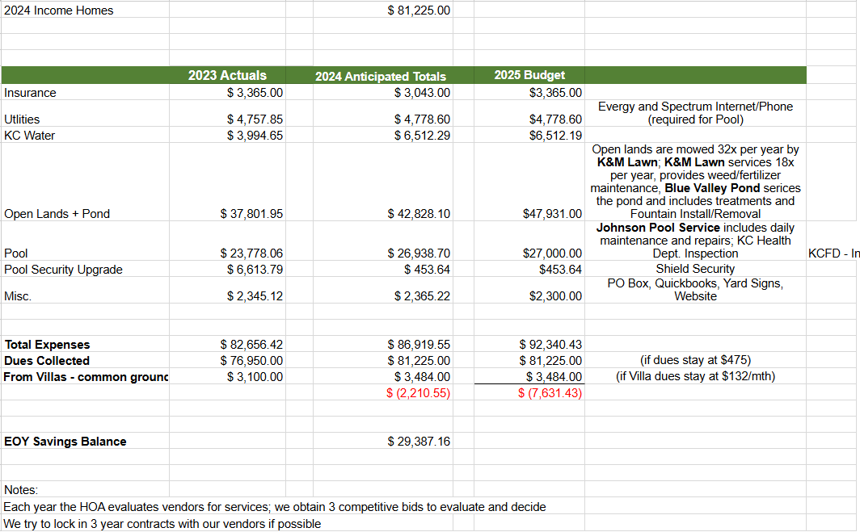

VILLAS BUDGET
